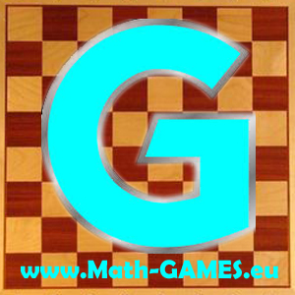
INVITATION
I invite you to the
Fourth Transnational Project Meeting
of the Erasmus+ project:
Math-GAMES - Games And Mathematics in Education for adultS Compendiums, Guidelines and Courses for Numeracy Learning Methods Based on Games
(2015-1-DE02-KA204-002260)

Each partner has to send its coordinator.

Programme

Date: Friday, 18th of November to Monday, 21th of November 2016

Place: MIE – Maison des initiatives étudiantes, 50 Rue des Tournelles, 75003 Paris, France,

https://www.facebook.com/mieparis/?fref=ts

Airport: Paris CDG, Paris Orly, Beauvais-Tillé

Website: www.math-games.eu

Aims of the meeting
- Evaluation of the Math-GAMES Numeracy Learning Guidebook in English
- Translation of the Learning Guidebook in national language
- Talk about the working process including the quarter reports and the administration
- Preparation of the next meeting, next work to do

Timetable (subject to modification)

Fr 18.11.2016 Arrival Day

Get-together (optional) - place and time to be decided.

Sat 19.11.2016 First Working Day

10:00 Meeting at the MIE

10:10 Working time
- The coordinator will make a short presentation about the progress of the project.
- Each country will present its work.
- Discuss changes, corrections, improvements.
- Discuss the next output (O2) and the coming timetable

13:15 Lunch

13:30 Meeting resumes

17:00 Expected end

20:00 Dinner at restaurant to be decided on the number of the participants

Sun 20.11.2016 Second Working Day (optional)

10:00 Work on project details at a French café

13:00 Lunch (individual, groups)

17:00 Short city tour

Mon 21.11.2016 Departure Day

Contact person: Voican Catalina

President of Connexion Roumanie

0033662388500

catalinavoican@gmail.com

